Model Solution Paper – Cloud Data Engineer - Jain University

TOTAL: 100 MARKS | Time Limit: 3 Hours

SECTION A: ADVANCED SQL || Maximum Marks: 20 Question 1: Database Design and Advanced Queries (8 Marks)
Create a database named EnterpriseDB.
Create the following tables.

Employees
Column | Description
EmployeeID | Unique employee identifier
EmployeeName | Employee name
DepartmentID | Department identifier
Salary | Monthly salary
JoiningDate | Date of joining
ManagerID | Employee ID of the manager

Departments
Column | Description
DepartmentID | Unique department identifier
DepartmentName | Department name
Location | Department location

Requirements:
- Define appropriate data types and constraints.
- Set primary keys and an appropriate foreign key.
- Insert at least 15 employee records and five department records.
- Include employees with different salaries, departments, and managers.
- Include at least one department without employees.

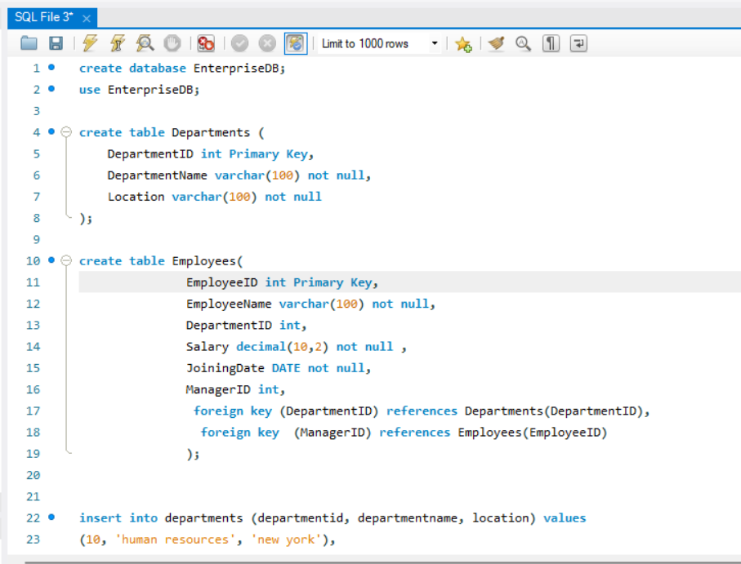

Tasks:
- Display employee names, department names, and manager names using joins. (2 marks) 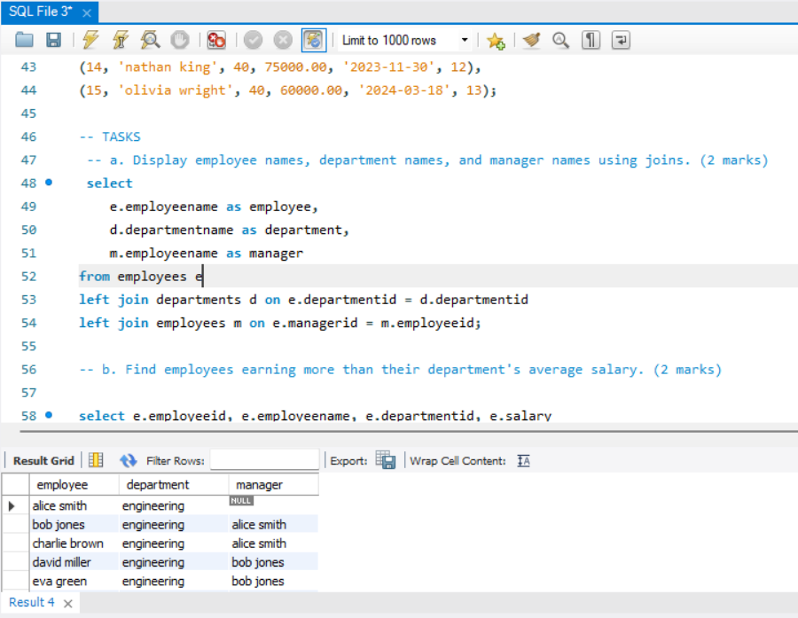

- Find employees earning more than their department's average salary. (2 marks) 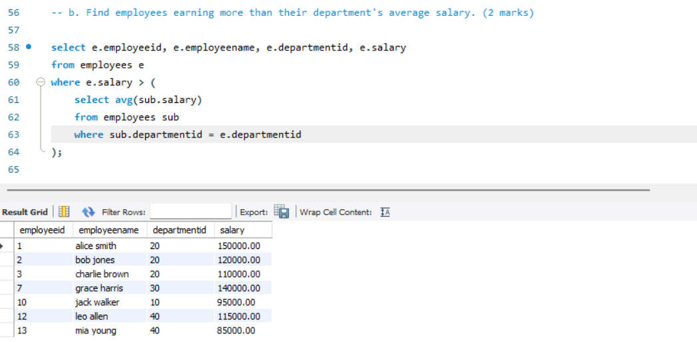

- Find the second-highest distinct salary without using LIMIT, TOP, or FETCH

FIRST. (2 marks) 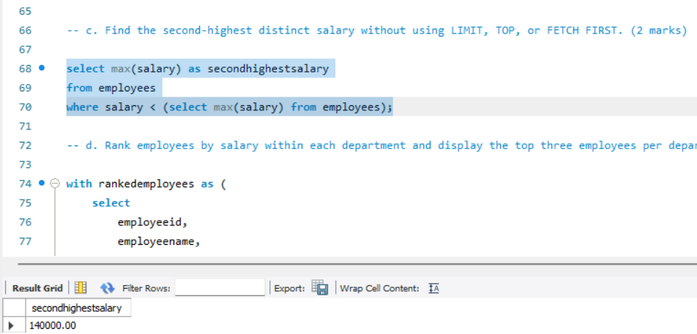

- Rank employees by salary within each department and display the top three employees per department, retaining ties at the cutoff. (2 marks)
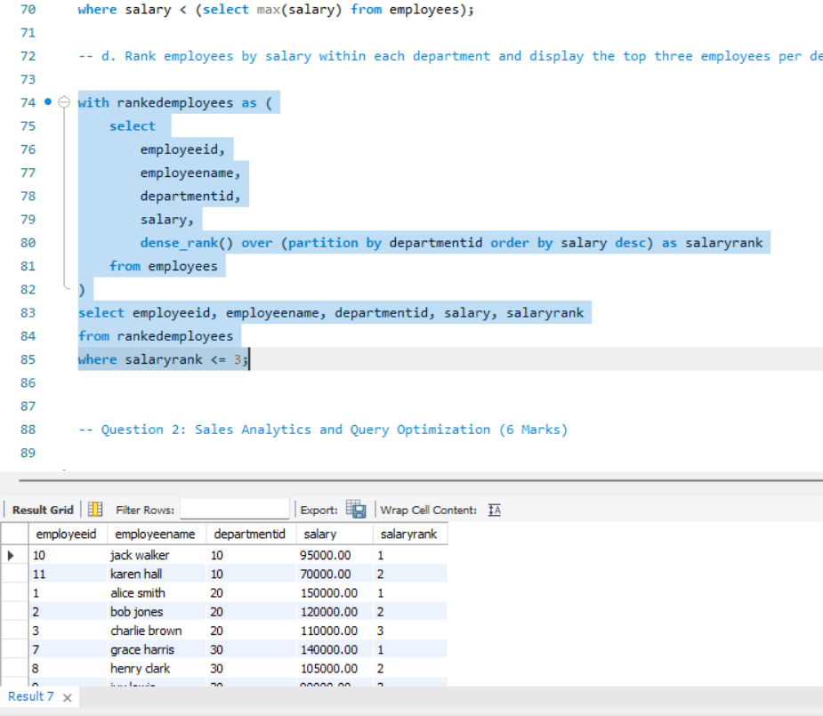

Question 2: Sales Analytics and Query Optimization (6 Marks)
Create a Sales table with the following columns:
- SaleID
- CustomerID
- SaleDate
- ProductName
- Quantity
- UnitPrice
Insert at least 15 sample records covering multiple customers, products, and dates.
Write SQL queries to:
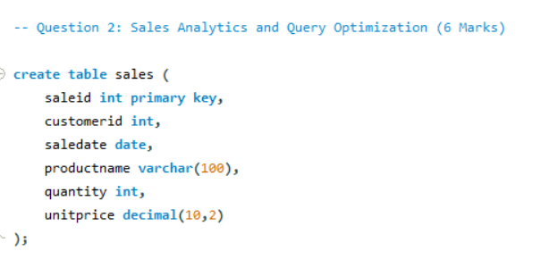
- Calculate total revenue for each product. (2 marks)
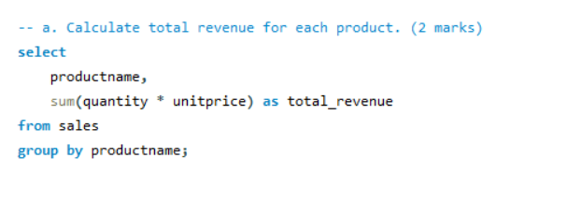
- Calculate monthly revenue and month-over-month revenue change using a window function. (2 marks)
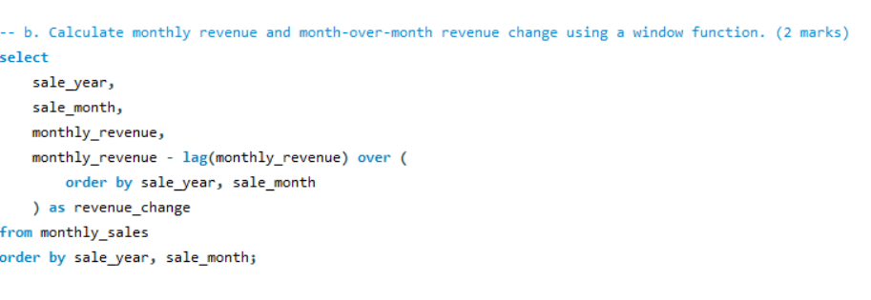
- Rewrite the following query to improve the potential for index usage and explain why your version may perform better. (2 marks)
SELECT *
FROM Employees
WHERE YEAR(JoiningDate) = 2025;
Assume JoiningDate may be indexed.
Ans :
SELECT *
FROM Employees
WHERE JoiningDate >= '2025-01-01' AND JoiningDate <= '2025-12-31';

Question 3: SQL Troubleshooting (6 Marks)
A company maintains millions of employee and transaction records. Its reporting queries are running slowly.
Perform the following tasks:
- Explain how an execution plan helps identify expensive operations in a query. (2 marks) :
Exposes Data Access Methods: It reveals if the database is using a costly Full Table Scan (scanning millions of rows) instead of an efficient Index Seek/Scan.
Highlights Costly Operations: It attaches a weight or percentage cost to each individual step (e.g., joins, sorts, aggregations), allowing developers to pinpoint the exact operation consuming the most CPU or I/O.
Flags Mismatches & Bottlenecks: It shows actual versus estimated row counts. Large discrepancies indicate stale statistics, which lead to suboptimal join choices (like a nested loop instead of a hash match).

- Recommend an appropriate index strategy for queries filtering employees by
DepartmentID and Salary. Explain your reasoning. (2 marks) :

CREATE INDEX idx_emp_dept_salary ON Employees (DepartmentID, Salary);

- Write a query to identify duplicate customer email addresses and display only addresses occurring more than once. (2 marks)
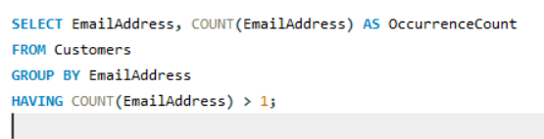

SECTION F: MICROSOFT AZURE || Maximum Marks: 15
Question 15: Azure Data Lake Storage and Security (5 Marks)
A company needs to store confidential business data in Azure for analytics.
Perform or document the following:
- Configure or describe a storage account with hierarchical namespace enabled for
Azure Data Lake Storage Gen2. (1 mark)
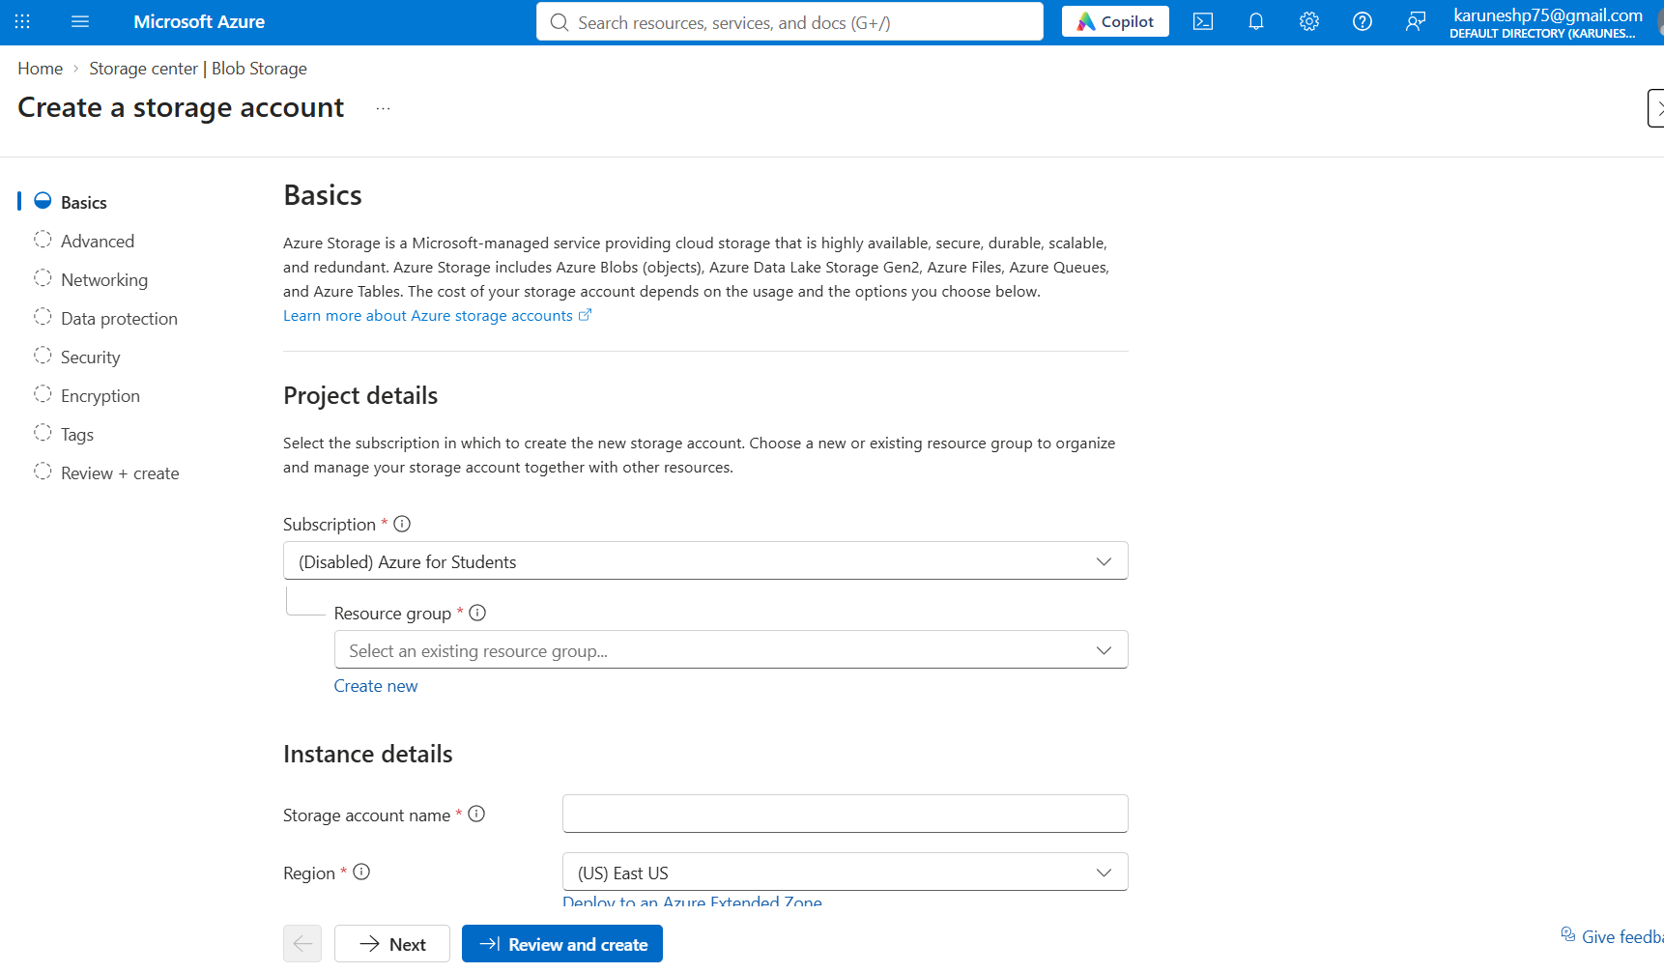
- Create a filesystem or container and upload a sample dataset. (1 mark)
- Explain how Microsoft Entra ID and Azure role-based access control can manage access to the data. (2 marks) :
Identity Authentication via Entra ID: All users, security groups, or application service principals must authenticate their identity securely using Microsoft Entra ID tokens instead of shared access keys.
Control-Plane Management (Azure RBAC): Azure RBAC roles are applied at the Storage Account or Container level to govern administrative operations. Standard built-in roles include:
Storage Blob Data Owner: Full control over storage container configurations and data.
Storage Blob Data Contributor: Permits reading, writing, and deleting blob/file assets.
Storage Blob Data Reader: Restricts access to read-only capabilities.

- Explain how you would verify that unauthorized users cannot access the dataset.

(1 mark) :
- Explicit Identity Testing: Have an unprivileged Entra ID test user or external client attempt to log into the storage account via Azure Storage Explorer, Azure Portal, or a PySpark connection string. The system must immediately throw a 403 Authorization Failed or StorageException: Access Denied error block.
- Public Access Verification: Generate the direct URL endpoint of the uploaded sample file (e.g., https://<account>.dfs.core.windows.net/container/transactions.csv) and attempt to access it through an anonymous browser incognito window. It should return a standard XML/JSON authentication block failure notice, proving anonymous public entry is disabled.
- Monitor via Azure Monitor logs: Inspect Storage Insights Diagnostic Logs to verify that failed unauthenticated queries are successfully flagged, categorized, and blocked by the Azure storage security firewall.

Question 16: Azure VM Troubleshooting (5 Marks)
A virtual machine is running in Azure, but administrators cannot connect to it.
Perform or document the following:
- Verify the VM's provisioning and power states. (1 mark)
Provisioning State: This represents the status of the Azure fabric deployment. It should say Succeeded. If it says Failed or Updating, the underlying hardware allocation or extension deployment failed, requiring a redeployment or reapply operation.

Power State: This represents the actual operational runtime state of the hardware. It must display Running. If it shows Stopped or Deallocated, the VM is turned off and cannot accept network traffic.

- Explain how Network Security Group rules can prevent connectivity. (1 mark)
A Network Security Group (NSG) acts as a stateful firewall controlling inbound and outbound traffic. It can block connection attempts through the following mechanics:
Missing Inbound Allow Rules: By default, all inbound traffic from the public internet is blocked by the default DenyAllInbound rule. If an explicit rule allowing your connection protocol—such as Port 22 for Linux SSH or Port 3389 for Windows RDP—is missing, the connection will drop.
Rule Priority Overrides: NSG rules are evaluated sequentially based on priority numbers (100 to 65000; lower numbers execute first). Even if you have a rule allowing port access at priority 500, a higher-priority rule (e.g., priority 200) that explicitly denies that same IP subnet or port will take precedence and block the traffic.

- Explain how subnet and routing configuration affect connectivity. (1 mark)
Traffic must find a valid path between your client machine and the VM network interface. Connectivity fails if errors exist within the Virtual Network (VNet) routing fabric:
Route Tables & UDRs: Azure automatically provisions system routes to direct traffic. However, if a User-Defined Route (UDR) is attached to the VM's subnet that overrides default paths for instance, routing all internet-bound traffic through a misconfigured or down network virtual appliance (NVA) or firewall the return traffic package gets lost in a routing black hole.
Missing Gateway/Peering Links: If you are trying to access the VM via a private network layout (such as a VPN or ExpressRoute connection), connectivity will drop if VNet Peering configurations are broken, or if the subnet's route table lacks a route directing private ranges to the Virtual Network Gateway.

- Recommend a secure troubleshooting method that avoids unnecessarily exposing the VM to the public internet. (2 marks)
Use Azure Bastion to establish a secure RDP/SSH session directly inside the Azure Portal browser via TLS/443 without assigning a public IP address to the VM. Alternatively, connect through the native Serial Console to troubleshoot lower-level guest OS boot errors over the secure Azure management plane.

Question 17: Azure Data Integration (5 Marks)
A company receives a CSV file containing daily customer transactions and needs to prepare it for analysis.
Design a solution using Azure services.
- Select an appropriate service to orchestrate data movement. (1 mark)
Selected Orchestration Service: Use Azure Data Factory (ADF) as the cloud architect to orchestrate data movements. It offers enterprise-grade scheduling, automated workflows, and native serverless connectivity across diverse storage environments.

- Explain how to copy the CSV file into Azure Data Lake Storage Gen2. (1 mark)
Copying to ADLS Gen2: Implement an ADF Copy Activity that maps data from your incoming source directory to the destination container. It manages compression, file parsing, and secure, high-throughput cloud loading automatically.

- Describe how to organize files by ingestion date. (1 mark)
Ingestion Date Organization: Apply dynamic time expressions within the ADF Sink folder path configurations to generate dated folders on the fly. This automatically segments files into structured paths like year=2026/month=10/day=28/ as they land

- Explain how to handle malformed records and missing values. (1 mark)
Handling Faulty Records: Route data through an ADF Mapping Data Flow to clean and process fields before saving. Use Conditional Split to isolate malformed rows into a separate error directory and Derived Column to substitute missing values with defaults.

- Explain how to monitor pipeline execution and validate data completeness. (1 mark)
Monitoring & Validation: Track runtime pipeline success, pipeline delays, and errors using the visual ADF Monitor Dashboard and Azure Monitor logs. Use Get Metadata activities to cross-verify row counts and file sizes between source and destination layers.

